DLAP Document Upload Deployment Guide

Change History

| Version # | Date | Modified By | Description |
| --- | --- | --- | --- |
| 1.0.0.0 | 01/24/2018 | Ashok Pudota | Initial DLAP Document Upload Deployment |
| 1.0.0.0 | 01/31/2018 | Ashok Pudota | Updated Name for the DLAP Document Upload Interface Dll’s and Orchestration. |
| 2.0.0.0 | 03/29/2018 | Ashok Pudota | Implemented Versioning 2.0.0.0  Updated Mapping  Added new field to the wsdl  Updated Orchestration logic to update Check List Status. |
| 2.0.0.1 | 04/10/2018 | Ashok Pudota | Updated Deployment Version from 2.0.0.0 to 2.0.0.1  Updated Content Version Mapping to pass Document Type.  Implemented Logic to process “ReceiptMetaData” and linking documents to Receipt object.  Removed logic for validating Check-list Item.  Increased request message limit size and timeouts. |
| 2.0.0.2 | 04/12/2018 | Ashok Pudota | Updated Deployment Version from 2.0.0.1 to 2.0.0.2  Updated logic to process metadata string xml |
| 2.0.0.3 | 04/17/2018 | Ashok Pudota | Updated Deployment Version from 2.0.0.2 to 2.0.0.3  Update Receipt mapping and linking Receipt file with Application. |
| 2.0.0.4 | 05/10/2018 | Ashok Pudota | Updated Deployment Version from 2.0.0.3 to 2.0.0.4  Updated Checklist Item Logic for Multiple Documents |
| 2.0.0.5 | 05/11/2018 | Ashok Pudota | Updated Deployment Version from 2.0.0.4 to 2.0.0.5  Updated Closed Document Check status mapping |
| 2.0.0.6 | 05/12/2018 | Ashok Pudota | Updated Deployment Version from 2.0.0.5 to 2.0.0.6  Updated Exception handling |
| 2.0.0.7 | 05/16/2018 | Ashok Pudota | Updated Deployment Version from 2.0.0.6 to 2.0.0.7  Updated Checklist Item Validity Logic |
| 2.0.0.8 | 05/17/2018 | Ashok Pudota | Updated Deployment Version from 2.0.0.7 to 2.0.0.8  Updated mapping for Document Metadata useofproceeds element. |
| 2.0.9.1 | 09/18/2018 | Ashok Pudota | Updated Deployment Version from 2.0.0.8 to 2.0.9.1  Removed CDATA Adapter.  Fixed following issues:  DCMM-5465 |

**Contents**

1. **Special Notes……………………………………………………………………………………………………………………….2** 
   1. **Username and Password instructions……………………………….…………………………………….2**
2. **Initial Deployment instructions ……………………………………………………………………………………………3**
3. **Re-Deployment** **instructions………………………………………………………………………………………………….6**

Special Notes:( DLAP Username and Password update instructions)

|  |  |  |
| --- | --- | --- |
| **Environment** | **DALP Update** | **Location** |
| DEV-INT | **UserName:** Dlap  **Password:** Basic2017 | Create a **local User** on server machine with username and password. |
| QA | Credentials: **N/A**  **check with Steven** | Create a **local User** on server machine with username and password. |
| PROD | Credentials: **N/A**  **check with Steven** | Create a **local User** on server machine with username and password. |

Username and Password update instructions:

1. Open **Local Users and Groups** on System Tools and Create **Username** and **Password**. for Dlap Service.

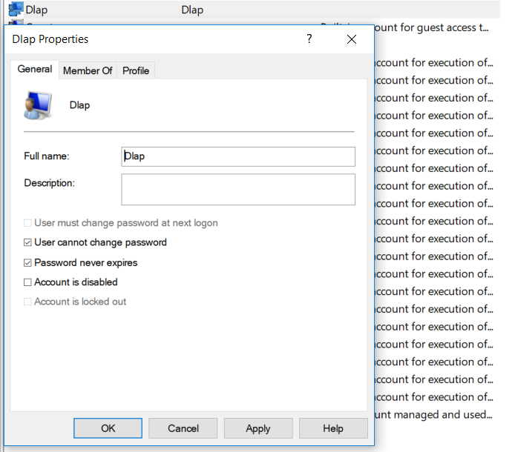

Initial Deployment Summary:

**Msi Installation:**

1. Open BizTalk Administration console and Import/Install the **DLAP Document Upload.msi** into the **Small Business Administration** application then complete the wizard by clicking Finish button and check mark the option Run Application Installation Wizard again to Install the MSI.
2. Next, import the **DLAP Document Upload Binding Info.xml** binding file after updating **Salesforce** send port configuration into the **Small Business Administration application.**
3. Start all the BizTalk artifacts related to **DLAP Document Upload as shown in the below Screen-shot**.

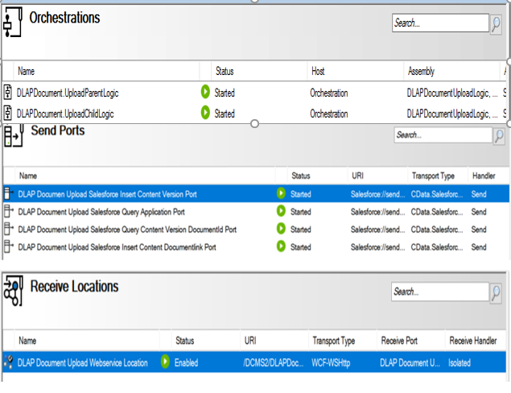

1. **Restart** All the **Host-instances.**
2. Open **IIS** (Internet Information System) right click on **DLAP Document Upload** Website and validate appropriate **Application Pool** (i.e. **DLAP Document Upload**) is selected.
3. Next, select **DLAP Document Upload** Website and go-to Authentication page on IIs and make sure **Basic Authentication** is **enabled** and remaining all are disabled as shown in the below screen-shot.

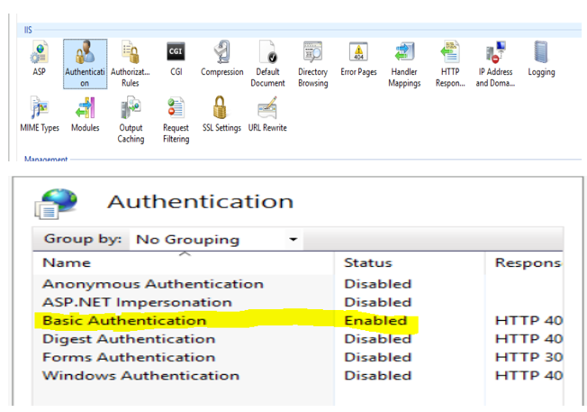

1. Next, Select **Authorization Rules** page on IIs and make sure only **Dlap User** is allowed as shown in the below screen-shot.

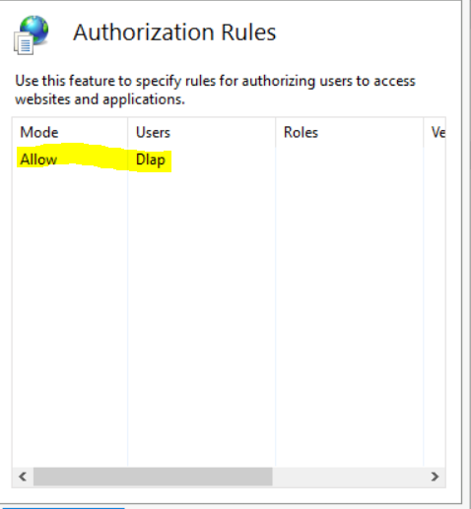

1. Reset/Re-start **IIS** (Internet Information System).
2. Browse the following **DLAP Document Upload** (HTTPS://) Website and make sure the site is up-running.

**Validate Application Being Deployed:**

1. Go to **BizTalk Administrator Console**, make sure **all** BizTalk artifacts related to **DLAP Document Upload Interface** are up-running.
2. Open **DLAP Document Upload Receive Location** and validate security properties as shown below.

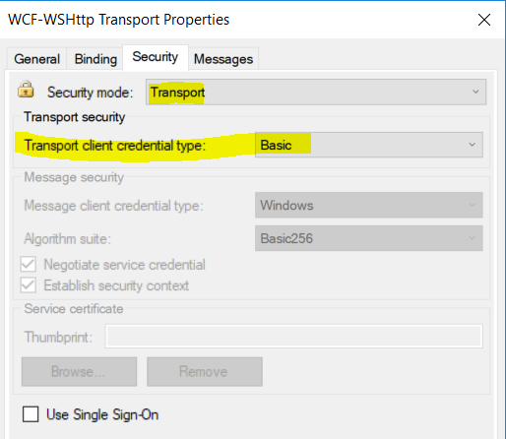

1. Go to **IIS**, make sure IIS is started.
2. Browse the **DLAP Document Upload** web site (HTTPS://) and make sure the site is up-running.
3. Open Soap-UI project attached on Deployment folder and post the sample message.

Re-Deployment instructions:

**Msi Installation:**

1. Go to BizTalk Administration Console **Stop and Unenlist all** the BizTalk artifacts related to **DLAP Document Upload Interface as shown in the below Screen-shot and Remove**

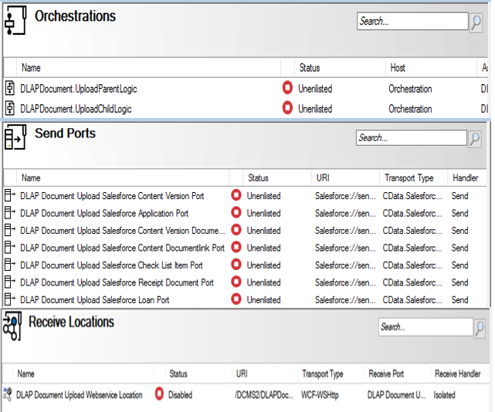

1. Remove Old Assemblies 2.0.0.8 and WEB Directory as show in the below screen-shot.

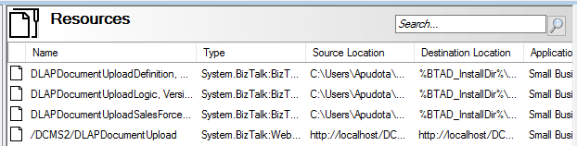

1. Next, Open **BizTalk Administration console** and **Import/Install** the **DLAP Document Upload 2.0.0.0.msi** into the **Small Business Administration** application then complete the wizard by clicking **Finish** button and check mark the option **Run Application Installation Wizard** again to Install the MSI.
2. Next, import the **DLAP Document Upload Binding Info.xml** binding file after updating **Salesforce** send port configuration into the **Small Business Administration application.**
3. **Start** all the **BizTalk artifacts (i.e. Receive location, Send ports and Orchestration)** related to **DLAP Document Upload** Interface.
4. **Restart** All the **Host-instances**.
5. Open **IIS** (Internet Information System) right click on **DLAP Document Upload** Website and validate appropriate **Application Pool** (i.e. **DLAP Document Upload**) is selected.
6. **Reset/Re-start IIS** (Internet Information System).
7. Browse the following **DLAP Document Upload** (HTTPS://) Website and make sure the site is up-running:

**Validate Application Being Deployed:**

1. Go to BizTalk Administrator Console, make sure **all** BizTalk artifacts related to **DLAP Document Upload** Interface are up-running.
2. Go to IIS, make sure IIS is started.
3. Browse the DLAP Document Upload web site (HTTPS://) and make sure the site is up-running.
4. Open Soap-UI project attached on solutionItems folder and post the sample message.